Blueprint Documentation

1-Blueprint Documentation structure

Knowledge Base

What is blueprint
# Source: AI Source: Provided by: [Data Path: Persons Table -> ID Column: 1, Name_En Column: Motasem Essam] -> From: [ChatGPT] on [7/14/2025]
A blueprint is essentially a detailed plan or design that guides creation or implementation. Think of it as a roadmap for how something should be built or how it should behave.

Rules and Guidelines

1-Documenting blueprint
# Source: AI Source: Provided by: [Data Path: Persons Table -> ID Column: 1, Name_En Column: Motasem Essam] -> From: [ChatGPT] on [7/14/2025]
each Blueprint can have multiple topics we called it Blueprint topics, each with its own Knowledge Base and Rules:
- Knowledge Base:
A collection of information that supports the topic, which may come from AI (like ChatGPT), documents, books, or other external sources. It provides the background knowledge and reference material needed to understand, design, and use the topic effectively.
- Rules and Guidelines: A set of instructions and constraints that determine how the topic should be applied or studied. Each topic can have a single sub-heading or multiple sub-headings, and each sub-heading can have one or more rules. These rules ensure consistency, accuracy, and ease of use across all materials and applications related to the topic.

2-Blueprint Path

Knowledge Base

What is Blueprint Path
# Source: AI Source: Provided by: [Data Path: Persons Table -> ID Column: 1, Name_En Column: Motasem Essam] -> From: [ChatGPT] on [7/14/2025]
A Blueprint Path is a structured way to reference the location of a Blueprint within a hierarchical folder system. It shows where the Blueprint is stored and helps in locating, organizing, or reusing Blueprint consistently.

Rules and Guidelines

1-Blueprint Path
# Source: AI Source: Provided by: [Data Path: Persons Table -> ID Column: 1, Name_En Column: Motasem Essam] -> From: [ChatGPT] on [7/14/2025]
- Always write the full path starting with Blueprint Path:.
- Use a hierarchical folder structure, separating folders with \ (backslash) or -> for readability.
- Include the Blueprint name or file name at the end of the path.

Format:
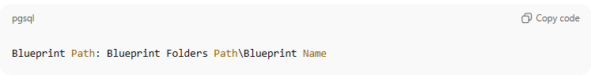
Blueprint Path: Blueprint Folders Path\Blueprint Name

or
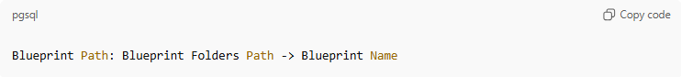
Blueprint Path: Blueprint Folders Path -> Blueprint Name
Examples
example
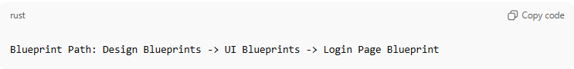
Blueprint Path: Design Blueprints -> UI Blueprints -> Login Page Blueprint
- Folders: Design Blueprint -> UI Blueprint
- Blueprint Name: Login Page Template

Another example
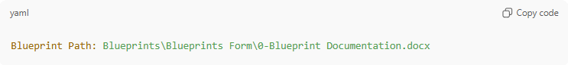
Blueprint Path: Blueprints\Blueprints Form\0-Blueprint Documentation.docx
- Folders: Blueprints\Blueprints Form
- Blueprint Name: 0-Blueprint Documentation.docx

3- Activity Checklist

Knowledge Base

✅ What is Activity Checklist?
# Source: AI Source: Provided by: [Data Path: Persons Table -> ID Column: 1, Name_En Column: Motasem Essam] -> From: [ChatGPT] on [10/27/2025]
A Activity Checklist is a structured step-by-step guide for an activity, where each step:
- Reminds you what to do — highlights the action or task you need to perform.
- Verifies that it was done correctly — records all relevant details of step.
- Explains why and what the benefits are — provides context, reasoning, and advantages of completing the step correctly.
It’s perfect when you need guidance while performing the task, not just a tick-off list.

🧩 In Your Use Case: Activity Checklist
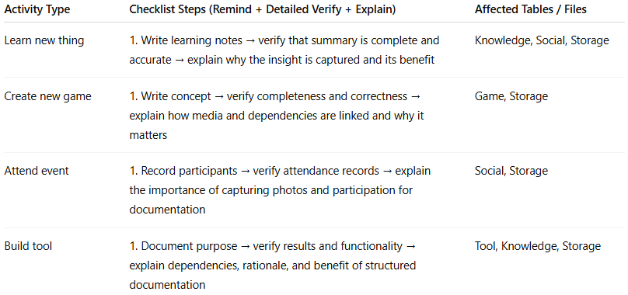
Activity Type | Checklist Steps (Remind + Detailed Verify + Explain) | Affected Tables / Files
Learn new thing | 1. Write learning notes → verify that summary is complete and accurate → explain why the insight is captured and its benefit | Knowledge, Social, Storage
Create new game | 1. Write concept → verify completeness and correctness → explain how media and dependencies are linked and why it matters | Game, Storage
Attend event | 1. Record participants → verify attendance records → explain the importance of capturing photos and participation for documentation | Social, Storage
Build tool | 1. Document purpose → verify results and functionality → explain dependencies, rationale, and benefit of structured documentation | Tool, Knowledge, Storage

⚙️ Why Use an Activity Checklist
- Converts a flow blueprint into actionable, step-by-step instructions
- Lets you follow, check, and understand each step in detail
- Useful for repeatable tasks, personal systems, and data management
- Adds traceability and accountability, so nothing is overlooked

Example
Organize Research Notes Activity Checklist (with explanations)
Steps
Step 1: Collect Notes
Step 2: Categorize Notes
Step 3: Summarize Key Points
Step 4: Record in Knowledge Table
Step 5: Backup and Share

Steps In Details
Step 1: Collect Notes
✅ Remind: Gather all notes from meetings, articles, and personal observations
✅ Verify: Ensure no notes are missing, duplicated, or incomplete
📝 Explain: Collecting all relevant information in one place allows easy access, prevents loss, and ensures nothing important is overlooked

Step 2: Categorize Notes
✅ Remind: Sort notes into categories (e.g., Topic, Project, Source)
✅ Verify: Check that each note is correctly placed in its category
📝 Explain: Organizing notes makes retrieval faster and keeps your knowledge system structured and efficient

Step 3: Summarize Key Points
✅ Remind: Write a concise summary for each category
✅ Verify: Confirm summaries capture main insights, supporting details, and key takeaways
📝 Explain: Summarization reduces information overload, highlights actionable insights, and improves comprehension

Step 4: Record in Knowledge Table
✅ Remind: Enter summaries and source references in the Knowledge Table
✅ Verify: Ensure each entry is complete, correctly linked to its sources, and stored in the proper category
📝 Explain: Creates a searchable, well-organized knowledge base for future reference, research, or collaboration

Step 5: Backup and Share
✅ Remind: Save notes, summaries, and table entries to cloud storage or GitHub
✅ Verify: Confirm all files are accessible, synced, and properly backed up
📝 Explain: Protects your work, provides a reliable backup, and allows sharing or collaboration with teammates

We now have a solid foundation for all your Activity Checklists with:
- Remind → what to do
- Verify → record all details, ensure completeness
- Explains → why to do it + benefits

Rules and Guidelines

1-Create Table Activity Checklist

Steps
# Source: AI Source: Provided by: [Data Path: Persons Table -> ID Column: 1, Name_En Column: Motasem Essam] -> From: [ChatGPT] on [10/27/2025]
Step 1: Create Table Access File
Step 2: Record new Table in [Tables] Table
Step 3: Add new Table to EventImpact Table and Update Events & EventPeriods Tables
Step 4: Update Data Collections File
Step 5: Upload Data Materials to GitHub

Steps In Details
# Source: AI Source: Provided by: [Data Path: Persons Table -> ID Column: 1, Name_En Column: Motasem Essam] -> From: [ChatGPT] on [10/27/2025]
Step 1: Create Table Access File
✅ Remind: Create a new Activity Table Access File to store all activity-related data.
✅ Verify:
- Confirm the file is created and accessible
- Record the file location, creation date, and any relevant versioning details
- Ensure the file can store all necessary fields for your activities
📝 Explain: This file acts as the central repository for all activity information. Proper creation ensures organized data management and makes future updates or audits easier.

Step 2: Record new Table in [Tables] Table
✅ Remind: Add the newly created Activity table to the [Tables] system table.
✅ Verify:
- Record all details: table name, description, file location, creation and update dates
- Confirm table is correctly linked in the system and visible in the catalog
- Ensure metadata is accurate and complete
📝 Explain: Recording the table ensures it’s part of your data catalog, making it traceable and accessible for reporting, analysis, or future reference.

Step 3: Add Activity to EventImpact Table and Update Events & EventPeriods Tables
✅ Remind: Link the Activity to relevant events in the EventImpact table and update associated event periods.
✅ Verify:
- Record which Events and EventPeriods the Activity affects
- Ensure all links are accurate and consistent with existing data
- Confirm the Activity is properly connected to its events for tracking purposes
📝 Explain: Proper linking allows you to analyze the impact of each Activity on events, ensures accurate reporting, and maintains data integrity across your system.

Step 4: Update Data Collections File
✅ Remind: Add or update a record for the Activity table in the Data Collections file.
✅ Verify:
- Record the table entry, folder links, and metadata in full
- Ensure all updates reflect the current status and structure
- Confirm completeness and consistency across the collection
📝 Explain: Updating the Data Collections file ensures your catalog is accurate, organized, and fully traceable, preventing missing data and improving overall system reliability.

Step 5: Upload Data Materials to GitHub
✅ Remind: Upload the folder containing the Activity table to your GitHub repository.
✅ Verify:
- Record the GitHub repository, branch, commit ID, and timestamp
- Confirm all files are uploaded, accessible, and properly versioned
- Ensure data integrity by checking file completeness and accessibility
📝 Explain: Uploading to GitHub provides a secure backup, enables collaboration, and ensures your Activity data is safely stored and trackable.

2-Knoweldge Activity Checklist

Steps
# Source: AI Source: Provided by: [Data Path: Persons Table -> ID Column: 1, Name_En Column: Motasem Essam] -> From: [ChatGPT] on [10/27/2025]
Step 1: Download and Record Sources in Sources table and in Sources Collections file in Resource folder
Step 2: Record Knowledge in Database and Update knowledge Collection
Step 3: Record as Folders in UploadsOrCreatedFolders
Step 4: Update Data Collections

Steps In Details
# Source: AI Source: Provided by: [Data Path: Persons Table -> ID Column: 1, Name_En Column: Motasem Essam] -> From: [ChatGPT] on [10/27/2025]
Step 1: Download and Record Sources in Sources table and in Sources Collections file in Resource folder
✅ Remind: Obtain knowledge materials (text, documents, videos, books, websites, AI outputs) from your chosen sources.
✅ Verify:
- All materials are saved in the Sources Table and in the Sources Collections file, organized by topic or category
- Each source is recorded in the Sources Table according to its type:
  - AI Source: Copy and store in the AI Source Folder and record in Sources Table
  - Learning / Multi-source / Wiki:
    - Videos: Create a map document linked to each video and record as a source
    - Books: Create a map document for each chapter and record as a source
    - Websites: Convert to PDF and record as a source
- Record file locations, dates, and any metadata associated with the sources
📝 Explain: Ensures all knowledge sources are preserved, categorized, traceable, and ready for integration or reference in the future. Proper recording prevents data loss and allows easy retrieval.

Step 2: Record Knowledge in Database and Update knowledge Collection
✅ Remind: Enter the knowledge into the appropriate Knowledge Category Table based on content type:
- Science and Formal Topics
- Natural Topics
- Social Topics
- Applied Topics
✅ Verify:
- Confirm each entry is in the correct category and fields table
- Record metadata such as source references, creation date, and any notes
- Ensure completeness and consistency across all entries
- Update knowledge Collection According to Category
  - Intro to Science Collection
  - Formal sciences Collection
  - Natural Science Collection
  - Social science Collection
  - Applied science Collection
📝 Explain: Categorizing knowledge makes it searchable, organized, and ready for integration into your knowledge system. Proper recording improves usability and prevents missing or misfiled information.

Step 3: Record as Folders in UploadsOrCreatedFolders
✅ Remind: Create and log corresponding folder structures in UploadsOrCreatedFolders for all new or uploaded knowledge artifacts.
✅ Verify:
- Confirm all new folders exist and are properly linked to the relevant knowledge entries
- Record folder names, paths, and associated activity references
- Ensure structure is consistent with your folder organization rules
📝 Explain: Maintaining a clear folder structure keeps knowledge artifacts organized, makes them easy to find, and ensures everything is properly tracked.

Step 4: Update Data Collections
✅ Remind: Add or update each new record in the Data Collections File
✅ Verify:
- Ensure all links between folders, databases, and tables are accurate
- Apply Data Collection and Data Size Suffix rules
- Follow the standard Data Collection Format
📝 Explain: Updating the Data Collections File keeps your knowledge system consistent, traceable, and fully up-to-date. Proper documentation prevents gaps, ensures reliability, and supports collaboration or future data analysis.

3-Skill Activity Checklist

Steps
# Source: AI Source: Provided by: [Data Path: Persons Table -> ID Column: 1, Name_En Column: Motasem Essam] -> From: [ChatGPT] on [10/27/2025]
Step 1: Download and Record Sources in Sources table and in source file in Resource folder
Step 2: Record Skill in Database and Update Skills Collection
Step 3: Record as Folders in UploadsOrCreatedFolders
Step 4: Update Data Collections

Steps In Details
# Source: AI Source: Provided by: [Data Path: Persons Table -> ID Column: 1, Name_En Column: Motasem Essam] -> From: [ChatGPT] on [10/27/2025]
Step 1: Download and Record Sources
✅ Remind: Obtain skill-related materials (training documents, videos, books, tutorials, reference websites) from your chosen sources, including AI outputs, learning platforms, multi-source collections, or wiki repositories.
✅ Verify:
- Save all materials in the Skill Source Folder, organized into subfolders by topic or category
- Record each source immediately in the Sources Table and in the Sources Collections file within the Resource folder, according to source type:
  - AI Source: Retrieve and store materials from the AI Source Folder and record in Sources Table
  - Learning / Multi-source / Wiki:
    - Videos: Create a map document linked to each video and record as a source
    - Books: Create a map document for each chapter and record as a source
    - Websites: Convert to PDF and record as a source
- Record file paths, source details, and timestamps for each entry
📝 Explain: Ensures all skill materials are preserved, organized, and traceable. Proper recording allows future reference, easy retrieval, and ensures nothing is missed during skill tracking or training.

Step 2: Record Skill in Database and Update Skills Collection
✅ Remind: Identify the skill type and record it in the appropriate database table:
- Theoretical Skill: Record in Theoretical Table and add details in Theoretical_Fields Table
- Practical Skill: Record in Practical Table; optionally include sub-fields or additional details
✅ Verify:
- Ensure each skill entry is complete, correctly categorized, and includes all relevant details
- Record source references, metadata, and any additional notes
- Update Skills Collection
📝 Explain: Proper categorization and recording of skills ensures your database is structured, searchable, and ready for analysis, training tracking, or reporting.

Step 3: Record as Folders in UploadsOrCreatedFolders
✅ Remind: Create and log corresponding folders in UploadsOrCreatedFolders for all associated files (videos, PDFs, project files).
✅ Verify:
- Confirm all folders exist and are properly linked to their respective skill entries
- Record folder paths, associated skill IDs, and any related metadata
📝 Explain: Maintaining an organized folder structure ensures easy access to skill resources, improves tracking, and prevents misplaced or lost files.

Step 4: Update Data Collections
✅ Remind: Add or update each new skill record in the Data Collections File
✅ Verify:
- Ensure links between folders, databases, and tables are accurate and complete
- Apply Data Collection and Data Size Suffix rules
- Follow standard Data Collection Format
- Record timestamps, file paths, and all relevant metadata
📝 Explain: Updating the Data Collections file keeps your skill system consistent, traceable, and fully up-to-date. Proper documentation allows efficient auditing, future reference, and ensures reliability across your system.

4-Work Knowledge Activity Checklist

Steps
# Source: AI Source: Provided by: [Data Path: Persons Table -> ID Column: 1, Name_En Column: Motasem Essam] -> From: [ChatGPT] on [10/27/2025]
Step 1: Download and Record Sources in Sources table and in source file in Resource folder
Step 2: Record Knowledge in Database and Update Work knowledge Collection
Step 3: Record as Folders in UploadsOrCreatedFolders
Step 4: Update Data Collections
Step 5: Upload Knowledge Materials and Sources Materials to GitHub

Steps In Details
# Source: AI Source: Provided by: [Data Path: Persons Table -> ID Column: 1, Name_En Column: Motasem Essam] -> From: [ChatGPT] on [10/27/2025]
Step 1: Download and Record Sources in Sources table and in source file in Resource folder
✅ Remind: Obtain work-related knowledge materials (documents, guides, workflows, templates, reports, videos, reference files) from your chosen sources — including AI-generated data, internal repositories, shared folders, learning portals, or wiki systems.
✅ Verify:
- Save all retrieved files in the Work Knowledge Source Folder, organized into subfolders by department, topic, or project
- Record each source in the Sources Table and in the Sources Collections file within the Resource folder, according to source type:
  - AI Source: Copy AI-generated content to the AI Source Folder and record in Sources Table
  - Learning / Multi-source / Wiki:
    - Videos: Create map documents linked to each video and record as a source
    - Books or Manuals: Create map documents for each chapter or section and record as a source
    - Websites: Convert to PDF and record as a source
- Record metadata, file paths, source IDs, and timestamps for every entry
📝 Explain: Properly recording and organizing work knowledge ensures traceability, easy retrieval, and prevents information loss. It also creates a clear record of sources for auditing or sharing with colleagues.

Step 2: Record Knowledge in Database and Update Work knowledge Collection
✅ Remind: Enter processed knowledge into the WorkKnowledge Table for main entries and into WorkKnowledgeFields Table for detailed classification.
✅ Verify:
- Include all relevant metadata: work category (e.g., HR, Finance, IT, Operations), Source ID, file path, CreatedDate, StoreDate, UpdateDate
- Confirm all entries are complete, accurate, and linked correctly to their sources
- Ensure hierarchical organization of topics and subfields is consistent
- Update Work knowledge Collection
📝 Explain: Recording knowledge in structured tables allows efficient searching, tracking, and analysis of work knowledge. Accurate metadata ensures clarity and usability for future reference or decision-making.

Step 3: Record as Folders in UploadsOrCreatedFolders
✅ Remind: Log all files and folders related to the work knowledge activity in UploadsOrCreatedFolders, maintaining a consistent folder hierarchy by department, project, or topic.
✅ Verify:
- Confirm all folders exist and are correctly linked to entries in the database
- Check folder paths, file types, and organization match the standard hierarchy
- Example structure:
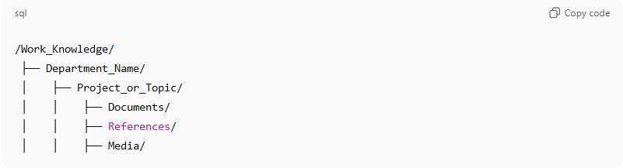
/Work_Knowledge/
├── Department_Name/
│ ├── Project_or_Topic/
│ │ ├── Documents/
│ │ ├── References/
│ │ ├── Media/
📝 Explain: Maintaining a standardized folder structure ensures files are easy to locate, share, and manage. It also supports consistent organization across all departments.

Step 4: Update Data Collections
✅ Remind: Add or update each new record in the Data Collections File to maintain accurate links between folders, databases, and tables.
✅ Verify:
- Ensure all links between folders, databases, and tables are correct
- Apply Data Collection and Data Size Suffix rules
- Follow the standard Data Collection Format
- Record timestamps, file paths, and changes for auditing purposes
📝 Explain: Keeping the Data Collections file up-to-date guarantees traceability, ensures consistency across the system, and supports collaboration or auditing.

Step 5: Upload Knowledge Materials and Sources Materials to GitHub
✅ Remind:
- Knowledge Materials: Upload all organized knowledge files (documents, references, media) to the Knowledge repository on GitHub
- Sources Materials: Upload all source files (metadata, cover images, references, reviews, translations, etc.) to the Resource repository on GitHub
✅ Verify:
- Record repository paths, branch names, commit IDs, and timestamps
- Confirm all files are uploaded and accessible
- Ensure folder structure matches UploadsOrCreatedFolders hierarchy
📝 Explain: Uploading to GitHub provides secure backup, supports collaboration, and ensures all work knowledge and sources are preserved and easily shareable across teams.

5-Download Music Activity Checklist

Steps
# Source: AI Source: Provided by: [Data Path: Persons Table -> ID Column: 1, Name_En Column: Motasem Essam] -> From: [ChatGPT] on [10/27/2025]
Step 1: Download and Record Sources in Sources table and in Sources Collections file in Resource folder
Step 2: Record in Tracks Table and Update Tracks Collection
Step 3: Record as Folders in UploadsOrCreatedFolders
Step 4: Update Data Collections

Steps In Details
# Source: AI Source: Provided by: [Data Path: Persons Table -> ID Column: 1, Name_En Column: Motasem Essam] -> From: [ChatGPT] on [10/27/2025]
Step 1: Download and Record Sources in Sources table and in Sources Collections file in Resource folder
✅ Remind: Obtain music tracks and all related files (album info, metadata, cover art, reviews, lyrics, documentation) from chosen sources — including streaming downloads, archives, shared libraries, or AI-generated sources.
✅ Verify:
- Save all downloaded files in the Music Source Folder, organized clearly by artist, album, or project
- Record each source in the Sources Table and in the source file within the Resource folder
- Include track details, origin, metadata, and any relevant file paths or timestamps for tracking
- Update Sources Collections
📝 Explain: Properly recording and organizing music sources ensures traceability, prevents data loss, and allows easy retrieval for future use, cataloging, or sharing.

Step 2: Record in Tracks Table and Update Tracks Collection
✅ Remind: Create a corresponding entry for each track in the Tracks Table
✅ Verify:
- Record all relevant fields: Track ID, title, Artist/Composer, Album/Project, Category or Mood, file path, related Source ID, CreatedDate, StoreDate, and UpdateDate
- Ensure all metadata is accurate and complete
- Confirm links between Tracks Table and Sources Table are correct
- Update Tracks Collection
📝 Explain: Recording each track in a structured table ensures your music library is searchable, well-organized, and fully linked to its sources for future reference or use in projects.

Step 3: Record as Folders in UploadsOrCreatedFolders
✅ Remind: Organize and log music files and folders in UploadsOrCreatedFolders following your folder naming structure
✅ Verify:
- Confirm all folders exist, are properly named, and correspond to the Tracks Table entries
- Record folder paths, file types, and related metadata
- Example structure:
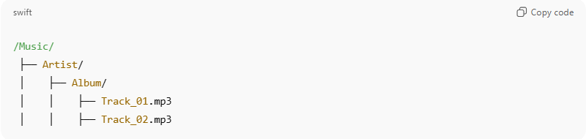
/Music/
├── Artist/
│ ├── Album/
│ │ ├── Track_01.mp3
│ │ ├── Track_02.mp3
📝 Explain: A consistent folder structure keeps your music library organized, makes retrieval easy, and ensures all files are properly tracked.

Step 4: Update Data Collections
✅ Remind: Add or update each new music record in the Data Collections File
✅ Verify:
- Ensure links between folders, Tracks Table, and Sources Table are complete and correct
- Apply Data Collection and Data Size Suffix rules
- Follow the standard Data Collection Format
- Record timestamps, paths, and all relevant metadata for auditability
📝 Explain: Keeping the Data Collections file updated ensures your music activity data is fully traceable, organized, and ready for future projects, analysis, or sharing.

6-Download Manga Volume Activity Checklist

Steps
# Source: AI Source: Provided by: [Data Path: Persons Table -> ID Column: 1, Name_En Column: Motasem Essam] -> From: [ChatGPT] on [10/27/2025]
Step 1: Download and Record Sources in Sources table and in Sources Collections file in Resource folder
Step 2: Record in SequentialArt Table and Update SequentialArt Collection
Step 3: Record as Folders in UploadsOrCreatedFolders
Step 4: Update SequentialArt Collection and Sources Collections
Step 5: Upload Manga and Sources Materials to GitHub

Steps In Details
# Source: AI Source: Provided by: [Data Path: Persons Table -> ID Column: 1, Name_En Column: Motasem Essam] -> From: [ChatGPT] on [10/27/2025]
Step 1: Download and Record Sources in Sources table and in Sources Collections file in Resource folder
✅ Remind: Obtain manga volumes, chapters, and related materials (reviews, cover art, summaries, author notes, translation files, metadata) from your chosen sources — including digital archives, libraries, publisher sites, or AI-generated sources.
✅ Verify:
- Save all downloaded files in the Manga Source Folder, organized into subfolders by series and volume
- Record each manga volume and its related materials in the Sources Table and in the source file within the Resource folder
- Include metadata such as source ID, file paths, timestamps, and material type for traceability
- Update Sources Collections
📝 Explain: Organizing and recording manga sources ensures everything is traceable, searchable, and preserved. It prevents lost files and allows easy reference for future work, analysis, or sharing.

Step 2: Record in SequentialArt Table and Update SequentialArt Collection
✅ Remind: Create a record for each manga volume in the Manga Table
✅ Verify:
- Record all fields: Manga ID, title, volume, chapter details, category/genre (e.g., Shonen, Seinen, Romance), linked Source ID, file path, CreatedDate, StoreDate, and UpdateDate
- Confirm all entries are complete, accurate, and properly linked to their sources
- Update SequentialArt Collection
📝 Explain: Recording manga in a structured table ensures the library is organized, searchable, and linked to all sources for efficient management and future reference.

Step 3: Record as Folders in UploadsOrCreatedFolders
✅ Remind: Organize and log all manga files and folders in UploadsOrCreatedFolders for structured storage
✅ Verify:
- Confirm all folders exist and follow the standard hierarchy
- Check that folder names match series, volumes, and chapters, and are linked correctly to database entries
- Example structure:
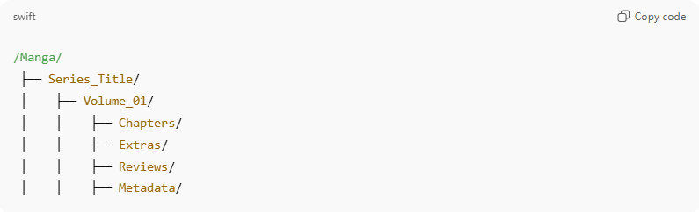
/Manga/
├── Series_Title/
│ ├── Volume_01/
│ │ ├── Chapters/
│ │ ├── Extras/
│ │ ├── Reviews/
│ │ ├── Metadata/
📝 Explain: Maintaining a consistent folder structure ensures files are easy to locate, share, and manage, and supports accurate linking between storage and database records.

Step 4: Update SequentialArt Collection and Sources Collections
✅ Remind: Add or update records in the SequentialArt Collections File and the Sources Collections File
✅ Verify:
- Confirm all entries are linked to the correct folders, database tables, and source files
- Apply Data Collection and Data Size Suffix rules
- Follow the standard Data Collection Format
- Record timestamps, file paths, and any metadata for traceability
📝 Explain: Updating collections ensures your manga library and sources are fully traceable, organized, and searchable. It prevents missing data and supports accurate cataloging.

Step 5: Upload Manga and Sources Materials to GitHub
✅ Remind:
- Manga Materials: Upload all organized manga files (volumes, chapters, extras) to the Manga repository on GitHub
- Sources Materials: Upload all source files (metadata, cover images, references, reviews, translations, etc.) to the Resource repository on GitHub
✅ Verify:
- Record repository paths, branch names, commit IDs, and timestamps
- Confirm all files are uploaded, accessible, and maintain the folder structure from UploadsOrCreatedFolders
- Ensure all files are complete and correctly linked to database entries
📝 Explain: Uploading to GitHub provides secure backup, supports collaboration, and ensures all manga and sources are preserved, organized, and easily shareable.

7-Download Gaming Activity Checklist

Steps
# Source: AI Source: Provided by: [Data Path: Persons Table -> ID Column: 1, Name_En Column: Motasem Essam] -> From: [ChatGPT] on [10/27/2025]
Step 1: Download and Record Sources in Sources table and in Sources Collections file in Resource folder
Step 2: Record in Games Table and Update Games Collection
Step 3: Record as Folders in UploadsOrCreatedFolders
Step 4: Update Data Collections

Steps In Details
# Source: AI Source: Provided by: [Data Path: Persons Table -> ID Column: 1, Name_En Column: Motasem Essam] -> From: [ChatGPT] on [10/27/2025]
Step 1: Download and Record Sources in Sources table and in Sources Collections file in Resource folder
✅ Remind: Obtain game files and all related materials (reviews, cover art, summaries, documentation, updates, or metadata) from your chosen sources — including digital archives, libraries, publisher sites, or AI-generated sources.
✅ Verify:
- Save all downloaded files in the Games Source Folder, organized into subfolders by game title and version
- Record each game and its related materials in the Sources Table and in the source file within the Resource folder
- Include metadata such as source ID, file paths, file type, and timestamps for traceability
- Update Sources Collections
📝 Explain: Proper recording of game sources ensures that all materials are preserved, traceable, and easily accessible. It prevents lost files and allows consistent cataloging for future use, reference, or distribution.

Step 2: Record in Games Table and Update Games Collection
✅ Remind: Create a detailed record for each game in the Games Table
✅ Verify:
- Record all fields: Game ID, title, category (e.g., Action, Simulation, Strategy), platform (PC, Console, Mobile), linked Source ID, file path/storage location, CreatedDate, StoreDate, and UpdateDate
- Ensure metadata is complete and accurately linked to the Sources Table
- Confirm all game details are correct and fully recorded
- Update Games Collection
📝 Explain: Structured recording in the Games Table ensures your gaming library is organized, searchable, and properly linked to all source materials for tracking, reference, and analysis.

Step 3: Record as Folders in UploadsOrCreatedFolders
✅ Remind: Organize and log all game files and folders in UploadsOrCreatedFolders for structured storage and management
✅ Verify:
- Confirm all folders exist and follow standard naming conventions
- Check that folder paths are consistent with the Games Table entries
- Example structure:
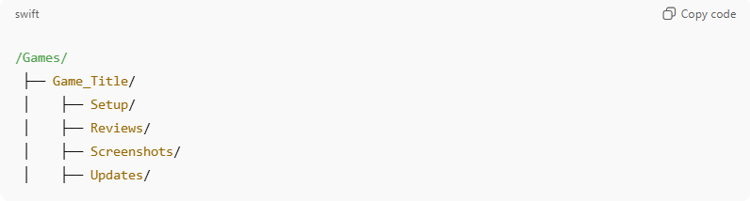
/Games/
├── Game_Title/
│ ├── Setup/
│ ├── Reviews/
│ ├── Screenshots/
│ ├── Updates/
📝 Explain: Maintaining a standardized folder structure ensures easy access, prevents misplaced files, and keeps your gaming resources organized for tracking, updates, or sharing.

Step 4: Update Data Collections
✅ Remind: Add or update each new game record in the Data Collections File
✅ Verify:
- Ensure links between folders, Games Table, and Sources Table are accurate and complete
- Apply Data Collection and Data Size Suffix rules
- Follow the standard Data Collection Format
- Record timestamps, paths, and all relevant metadata for traceability
📝 Explain: Updating the Data Collections File guarantees that your gaming activity data is fully traceable, organized, and consistent across your system. This supports future reference, reporting, and collaboration.

